Dear Van Hise Kindergarten Families, July 24, 2015

The kindergarten teaching team at Van Hise Elementary this school year includes Ms. Butler, Ms. Mileham, Ms. Riecke, Mrs. Anderson Delgado, and Ms. Lieberman. We are excited to have your child in our kindergarten classes this year! We are looking forward to meeting you and your child so we can grow a strong home-school relationship.

In the first few weeks of school we will be doing many community-building activities with your children to get to know them better. Throughout the year we will share students for instruction across classrooms. This allows us to individualize instruction for students with similar academic needs. For example, your child may move to a different class for reading group and this may change multiple times throughout the year, as teachers re-group students based on their learning needs.

We will also share students for social studies and science, with students rotating through all of the kindergarten classrooms for instruction. During the first quarter:
- Ms. Riecke will teach your child the kindergarten science curriculum, a curriculum that begins by focusing on basic structures and behaviors of various animals.
- Ms. Butler will teach the Second Step social studies curriculum, helping students learn to identify emotions, self-regulate, and get along with others in a school environment.
- Ms. Mileham will teach the Social Studies Alive curriculum, focusing on themes that teach about our place in the world.

All of the curricula that we use in the classroom—from the MONDO Bookshop literacy curriculum to the Investigations and Vandewalle math curricula and the others mentioned above—will help us to make sure your child’s instruction aligns with the Common Core State Standards. You can learn more about these standards at:

http://www.corestandards.org/
We look forward to building a strong community of learners this year! We are fully committed to your child’s academic and social-emotional growth. As your child enters their elementary school experience we are excited to guide them onto the path of lifelong learning!
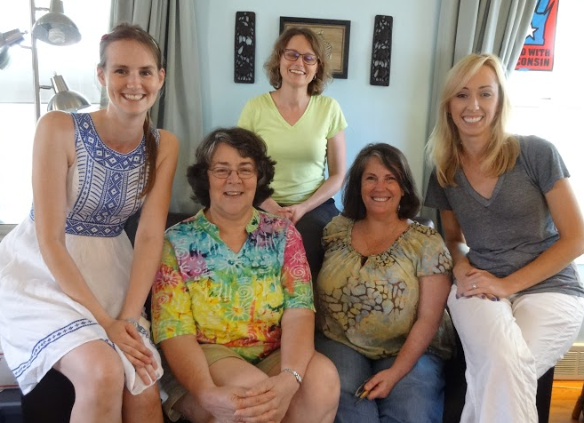
Sincerely,
The Kindergarten Team

Mary Butler, Classroom Teacher, Rm 105
mebutler2@madison.k12.wi.us

Edie Mileham, Classroom Teacher, Rm 101
emileham@madison.k12.wi.us
JoAnn Riecke, Classroom Teacher, Rm 103
jriecke@madison.k12.wi.us

Sue Anderson Delgado, Bilingual Resource Teacher
sdanderson@madison.k12.wi.us
Breah Lieberman, Special Education Teacher Pictured from left to right: Ms. Mileham, Ms. Riecke, bmlieberman@madison.k12.wi.us Mrs. Anderson Delgado, Ms. Butler, & Mrs. Lieberman

